**SQS**

1. Create a FIFO SQS queue

1. Test by sending messages

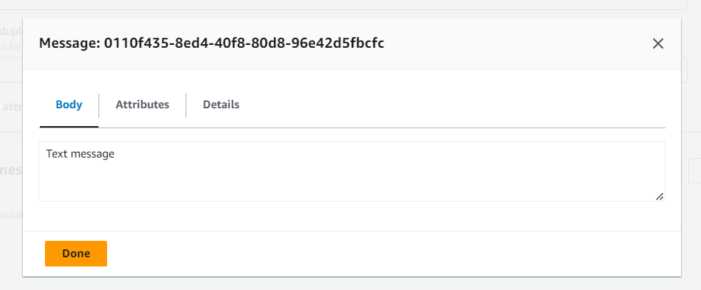

**SES**

1. Creating identity for verifying the mail in SES

1. Sending test mail

